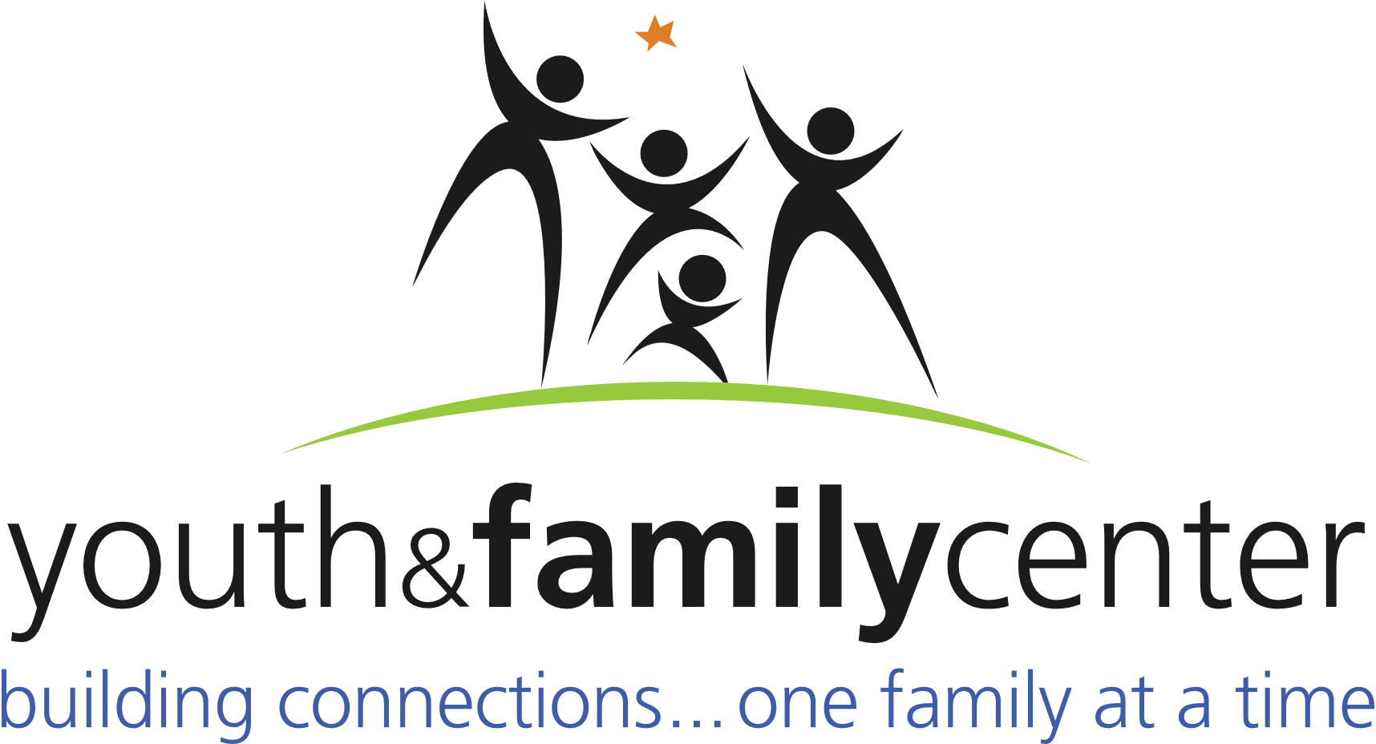

Position: Program Mentor (Floater)
The Youth and Family Center, a proud partner of United Way, is seeking a part time Program Mentor to work with our After School program. This person will report to the Program Manager. The person in this role will maintain a safe learning environment that is responsive to the social/emotional, physical, cognitive, and language development of children.
Requirements:
- Facilitate activities to support youth involvement and inclusion.
- Ability to build rapport with children and families.
- Ability to work individually and in a team setting.
- Time management skills and the ability to multi-task project
- Must demonstrate developmentally appropriate behavior management strategies.
- Exercise initiative and judgment in performing job
- Must commit to the following characteristics when interacting with co-workers, children, families, and members of the community: respectful, nurturing, caring, patience, culturally sensitive, creative, team player, and possess a positive, non-threatening attitude.
- Ability to understand oral and written instructions and effectively communicate with students, parents, and peers.
- Must demonstrate the ability to work under minimal supervision.
Duties and Responsibilities (Including, but not limited to, the following):
- Provide homework support.
- Assist with daily activities (restroom use, lunch/snack, hand washing) as needed
- Establish a professional rapport with each student and family in order to provide
quality care and support.
- Maintain a professional self-image and project the values of the organization at
all times.
Qualifications:
- High School diploma or equivalent
- Two years successful work experience in a related field
- Must be able to pass a criminal background check by hiring date
To apply please email resume and three professional references to
scotton-johnson@theyfc.org. No phone calls please.

Compensation: $12 per hour

